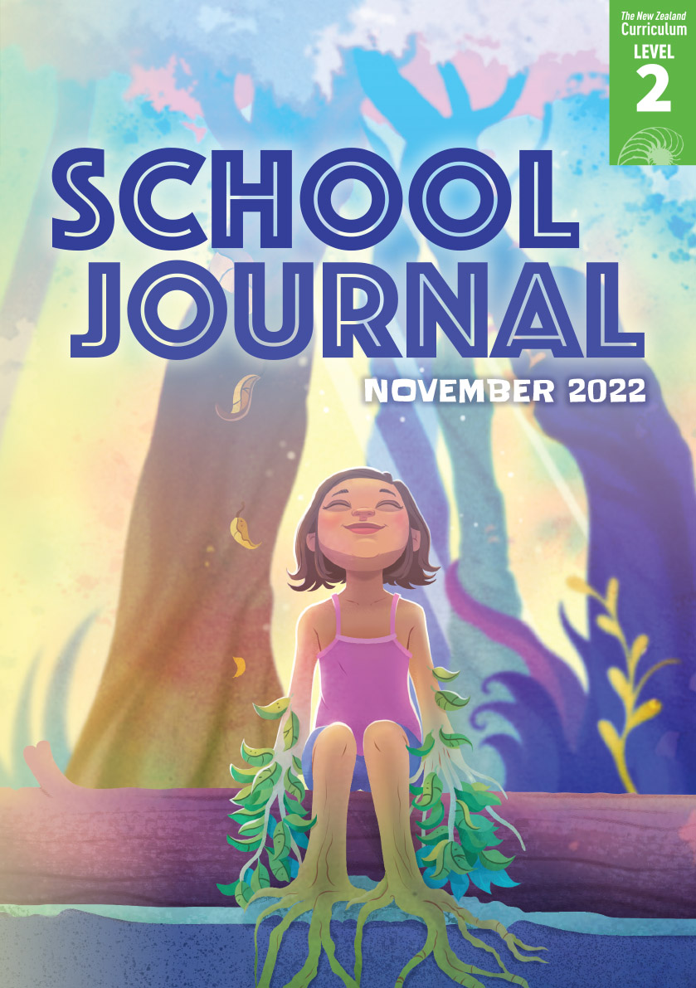

School Journal

Level 2, November 2022

**Reading level year 3**

# Saving the Lizards

by Iona McNaughton

The[Learning Progression Frameworks](https://curriculumprogresstools.education.govt.nz/lpf-tool/) (LPFs) describe significant signposts in reading and writing as students develop and apply their literacy knowledge and skills with increasing expertise from school entry to the end of year 10.

## Overview

Before work began on Transmission Gully near Wellington, several species of native lizard were found to be living in the path of the motorway. These lizards were moved to Ngā Manu Nature Reserve in Waikanae, where they stayed for two years. Special homes made from rock piles, which protect the lizards from predators, were built for them to live in when they were returned to the hills.

A PDF of the text is available at [www.schooljournal.tki.org.nz](http://www.schooljournal.tki.org.nz)

## Themes

“Saving the Lizards” connects to the theme of kaitiakitanga. Other texts in this Journal (and the levels 3 and 4 journals for November 2022) also focus on this theme. This article is scaffolded for extra support and is designed to build knowledge and introduce the important ideas and vocabulary connected with the theme of kaitiakitanga. On page 5 of this TSM, there is an overview of all the texts in this Journal, including a list of themes for each text. There is also a link to the audio for this text, which provides further support so ākonga can revisit the story as often as they   
need to.

The theme of kaitiakitanga refers to guardianship, care, protection of land and water, and the passing on of traditional knowledge.   
In te ao Māori, people are believed to have whakapapa connections within the natural world. All people share a responsibility to care for the environment. Among the texts that focus on kaitiakitanga in this Journal, there are stories and articles that convey the message that if we care for nature, nature will care for us.

**Other themes that can be explored in this text include:**

• Conservation • Environment • Te ao Māori

## Related texts

**“Kaitiakitanga”** *Connected* L3 Dec 2020 | **“A New Home for Mokomoko”** *Junior Journal* 43 | **“Bringing Back the Birdsong”** *Connected* L2 Aug 2017 | **“The Fish Highway”** *Connected* L3 Jan 2013 | **“Counting Kākahi”** *Connected* L3 Jan 2014

## Strengthening reading behaviours (what to notice)

|  |  |
| --- | --- |
| Text structure and features | Requiring students to: |
| * Abstract ideas   *They discovered that no native birds or bats were in danger from the motorway. But they did find that some native fish and lizards were threatened.* (page 30) | * use their vocabulary knowledge, as well as the sentence structure and context of the article, to work out what the danger from the motorway might be and why some native fish and lizards were threatened |
| * Implied information   *It was important that the environment was left in better condition when the motorway was finished.*  (page 32) | * use their vocabulary knowledge and the context of the surrounding sentences to work out what “condition” means and then visualise the scene being described to understand what “better condition” means. |

|  |  |
| --- | --- |
| Vocabulary | |
| Possibly challenging words and phrases | native lizards, Ngā Manu, nature reserve, threatened, kaumātua, Ngāti Toa, Te Āti Awa ki Whakarongotai, blessed, kaitiaki, reptiles, protect, environment, pests, skinks, geckos, predators, ferns, moths, maggots, scales, sheds, measured, weighed, designed, released, thriving |
| Helpful prior knowledge (pre-reading and introducing the text) | |
| * Some knowledge of the location of Transmission Gully and the Ngā Manu Nature Reserve (you could refer ākonga to the map on page 30 – it may be useful to compare this with a map of New Zealand so ākonga can find their own location.) * Some knowledge of the features and characteristics of lizards and the predators who might threaten them * Some awareness of the concept of kaitiakitanga – you could discuss and explore ākonga knowledge of kaitiakitanga in te ao Māōri and the role of kaitiaki. * The idea of moving species from their habitat and looking after them until it is safe to return them to their homes. (You could use [footage of the motorway](https://www.nzta.govt.nz/projects/wellington-northern-corridor/transmission-gully-motorway/videos/) to prompt discussion about why its construction posed such a threat. Ākonga could share their knowledge about safe habitats being created in reserves and sanctuaries and why people do this.) | |

## Possible reading and writing purposes

* Find out how some native species were saved when a new road was built
* Identify and describe the actions taken to protect the lizards’ habitat
* Explain what it means to be a kaitiaki

See *Effective Literacy Practice in Years 1–4* for suggestions on using this text with your students ([Approaches to teaching reading](http://literacyonline.tki.org.nz/Literacy-Online/Planning-for-my-students-needs/Effective-Literacy-Practice-Years-1-4/Approaches-to-teaching-reading)) and for information about teaching comprehension strategies ([Building comprehension](http://literacyonline.tki.org.nz/Literacy-Online/Planning-for-my-students-needs/Effective-Literacy-Practice-Years-1-4/Building-comprehension) and [Text processing strategies](http://literacyonline.tki.org.nz/Literacy-Online/Planning-for-my-students-needs/Effective-Literacy-Practice-Years-1-4/Text-processing-strategies)).

## Possible curriculum contexts

## This text has links to level 2 of the New Zealand Curriculum in English, science, and technology.

## Understanding progress

The following aspects of progress are taken from the [Learning Progression Framework](https://curriculumprogresstools.education.govt.nz/lpf-tool/)s (LPFs) and relate to the specific learning tasks below. See the LPFs for more about how ākonga develop expertise and make progress in these aspects:

* Acquiring and using information and ideas in informational text
* Making sense of text: using knowledge of text structure and features
* Reading to organise ideas and information for learning
* Using writing to think and organise for learning

## Strengthening understanding through reading and writing

**After the first reading of “Saving the Lizards”,** **select from the following suggestions and adapt them** according to the strengths, needs, and experiences of your ākonga. Most of these activities lend themselves to ākonga working in pairs or small groups.

* EXPLORE the connection between the article and the theme of kaitiakitanga by having ākonga discuss the different ways the theme is demonstrated through the actions of the motorway contractors, the staff at Ngā Manu, and the kaumātua from the local iwi.
* PROMPT ākonga tonotice that the text isn’t strictly chronological. Have them identify time-sequence words, including those that indicate when the order of events jumps around, such as “before” and “during”, and construct a simple timeline of these events. Use this to prompt discussion about why the lizards were moved, how this was done, and who was involved.
* MODEL how to ask questions before and during reading and actively look for specific information as you read. For example: *How did the staff at Ngā Manu take care of the lizards? Let’s read page 33 to see if we can find out.*
* ENCOURAGE ākonga tomake and check predictions about the information in the text boxes. Model how they could turn the subheadings into questions (for example, “What is Ngā Manu?”). For each text box, have them identify the main ideas conveyed in the topic sentences and then the supporting facts, examples, and other information. Prompt them to make connections between the text boxes and the body text. *Why has the author provided this extra information? How does it help us to understand the process for saving the lizards and the theme of kaitiakitanga?*
* MAKE CONNECTIONS between the descriptions of the skinks and geckos in the table and the photos on page 34. Foster critical literacy by prompting ākonga to discuss whether they obtained more information from the pictures or the words, or whether they needed both.
* Ask ākonga to WRITE a paragraph comparing skinks with geckos, using the table on page 34. Prompt them to notice that the paragraph that precedes the table already provides them with their topic sentence. Model how the table can be used as a speaking and writing [frame](https://esolonline.tki.org.nz/ESOL-Online/Planning-for-my-students-needs/Resources-for-planning/ESOL-teaching-strategies/Writing/Writing-frames-or-text-frames), with ākonga first reading their sentences to a partner and then writing them down. Discuss the need to use comparative conjunctions, such as “whereas” or “while”, and record examples they can refer to.
* CREATE a table comparing two other examples of native fauna that are similar but different (for example, gulls and terns, or kiwi and weka).
* DISCUSS the concept of a “natural habitat” and review the information about the features of a safe and inviting habitat for lizards. Read this Department of Conservation article about how to [attract lizards to your garden](https://www.doc.govt.nz/get-involved/conservation-activities/attract-lizards-to-your-garden/). Synthesise the information and then design and build a lizard habitat at school. Have ākonga record what they are doing and why, the steps involved in creating the habitat, and their observations of any lizards that move in. Note the warning that it is best not to touch the lizards. Ākonga could use the information in the articles to inform the design of their habitat. *How successful were we? What things affected the success of our design? How does it feel to take action as kaitiaki? How can kaitiakitanga be part of our daily lives?*
* USE the “Reflecting on the text” template on page 4 of this TSM as a tool for ākonga to describe what the concept of kaitiakitanga is and what it is not. Draw out that while we see people practising kaitiakitanga, people also cause the threat. Ask ākonga to use the word “kaitiakitanga” in a sentence and sketch what it might look like. Finally, have them describe a way they could – or already do – practise kaitiakitanga themselves.
* EXPLORE with ākonga how people preserve and promote traditional practices to protect the environment. For example, the kaumātua said a karakia or gave a blessing when the lizards arrived at Ngā Manu and then when they arrived at their new home near the motorway. For example, rāhui is a practice that Māori initiate to protect the environment or to show respect after a tragedy has occurred.
* ENCOURAGE ākonga to think about how their own culture has similar themes or concepts around kaitiakitanga (guardanship), protecting land, culture, animals, and sea creatures. *In your culture, is there a similar connection between people and the natural world? How is this reflected in the way you care for the environment? What words do you use in your culture to describe these ideas?*

## If ākonga need extra support

* Prompt them to share their knowledge of native lizards and why they think they might need to be saved.
* Have ākonga highlight any unfamiliar vocabulary and concepts, sentences they find difficult, or places where they were confused. Discuss strategies for working them out such as using decoding, word knowledge, context clues, and the glossary.
* Create “before” and “after” vocabulary grids for key words such as “habitat”, “threaten”, and “pest”. Prompt ākonga to write definitions without referring to a dictionary and then refine them as they read. They could then use the words to say and write sentences that summarise information from the text. The terms could be explored by creating a mind map together.
* If necessary, model the pronunciation of the kupu Māori. The audio version provides support. Discuss the relationship between the words “kaitiaki” and “kaitiakitanga”.
* Share-read with ākonga where necessary and provide the audio for them to revisit the story as often as they need to.
* If necessary, support ākonga to build noun phrases that include two or more adjectives and an adjectival phrase or clause to describe skinks and geckos or their habitats. For further practice, they can write captions for photos from the text or of other types of fauna.
* Review the structure of a typical paragraph. For example, together you could identify the main idea and supporting detail for the first paragraph on page 30. Then ask ākonga to identify the main ideas for the second and third paragraphs. Explain that a paragraph’s main idea is usually within a topic sentence, which is often the first sentence. The topic sentence provides a summary that helps the writer organise the information in the paragraph. As ākonga read on, encourage them to identify examples where the topic sentence is not the first sentence and discuss why that might be. Ākonga could reconstruct a text that has been cut up into sentences or paragraphs. This task will help them to notice topic sentences and the links within sentences through connectives like prepositions, adverbs, and conjunctions.
* Provide a [graphic organiser](http://esolonline.tki.org.nz/ESOL-Online/Planning-for-my-students-needs/Resources-for-planning/ESOL-teaching-strategies/Thinking-and-metacognition/Graphic-organisers) so ākonga can summarise the information from the text to help them organise their ideas and reuse the language.

## Reflecting on the text: **“Saving the Lizards”**

|  |  |
| --- | --- |
| **Kaitiakitanga** | |
| Definition and synonym: | Antonym: |
| Use it: | Sketch it: |
| Do it: | |

## School Journal | Level 2 | November 2022

Exploring a theme: The texts marked with a  share the theme of kaitiakitanga.

|  |  |  |  |  |
| --- | --- | --- | --- | --- |
|  |  | **Reading level** | **Themes** | **Curriculum  links** |
|  | Estuaries ARTICLE  Estuaries help protect our environment. It’s important that we protect and preserve them so they remain havens for the amazing variety of plants and animals that live there. | Year 4 | Kaitiakitanga  Environment  Climate change | English  Science  Social Sciences |
|  | Kaitiaki of the Estuary article  The students at Maungatapu School in Tauranga Moana monitor the sea life in their local estuary. But they are worried. They’ve noticed that they are finding fewer sea creatures each time. | Year 4 | Kaitiakitanga  Environment | English  Science  Social Sciences  Technology |
|  | Protecting the Waterways interview  Des Heke Kaiawha helps protect the waterways of Tauranga. He talks to Keri Welham about what the estuary was like when he was growing up and why it has changed. | Year 4 | Kaitiakitanga  Environment | English  Science  Social Sciences |
|  | Saving the Lizards ARTICLE  In 2015, eighty native lizards were moved to Ngā Manu Nature Reserve because their homes were in the path of the new Transmission Gully motorway near Wellington. The lizards stayed at Ngā Manu until new homes were made for them near the motorway. | Year 3 | Kaitiakitanga  Environment | English  Science  Technology |
|  | Taniwha article  This article describes the role of taniwha as kaitiaki in te ao Māori. Māori tell many stories about taniwha. They have worked together with taniwha for hundreds of years and think of them as very special kaitiaki. | Year 4 | Kaitiakitanga | English  Science |
|  | Hukarere and Hine Tai story  Hukarere is fascinated by taniwha. Her nan tells her there is a taniwha called Hine Tai who visits a rock pool near where they live. Hine Tai is their kaitiaki – she brings the riches of the ocean, such as fish and mussels, as a gift and helps keep the ocean clean. | Year 4 | Kaitiakitanga  Environment | English  Social Sciences |
|  | Tree Talk story  When Ruby and Sefa get lost in the forest they have an encounter with the trees. | Year 4 | Environment  Climate change | English  Social Sciences |
|  | Ocean View Student Writing  A student from Oteha Valley School in Auckland writes about a place that is special to her. | N/A |  | English  Social Sciences |